Crowd Synergy: YOLO meets ByteTracker
Vijay Bhargav Bhamidi¹, and Yajnaseni Dash²
School of Computer Science Engineering and Technology, Bennett University, Uttar Pradesh, India.
¹vijaybhargav148@gmail.com, ²yajnasenidash@gmail.com
Abstract- This paper proposed a method to count people or objects entering or exiting a certain area under certain conditions such as crossing an imaginary line using advanced one-stage object detection YOLOv8. It is assumed that each object is counted and does not miss any object. Every bounding box that crosses a line in one way is defined as an object going in and the total count is incremented. A bounding box that crosses the line in the opposite direction is considered an object going out and the total count should be decremented. The proposed methodology ensures that it has less computational overhead and no objects are missed by one-stage detection. Here, the accuracy of the bounding box of one-stage object detection demonstrates better detection and less false positives. This ensures that not only all objects detected are counted but also that no object present in the feed is missed.
Keywords: Object Detection, YOLOv8, Byte-Tracker, Object Counter.
- Introduction
Precisely counting objects or people as they enter or exit an area is sometimes very important in crowded areas for various applications like crowd management, security surveillance, etc. Traditional and previous methods rely on complex and multiple-stage processing algorithms which leads to missing certain objects. In this paper, we present a novel approach that uses a one-stage object detection i.e. YOLOv8 to achieve accurate detection.
Along with accurate detection, each bounded box detected by YOLOv8 is given a tracker. Then the object or person passes through a line which determines the count depending on the movement direction. Objects or people moving in one direction are considered to be entering the area and vice versa.

- Literature Review
Object detection is a computer vision task in which the goal is to identify and spot objects of interest in an image or video. This task involves identifying the location and boundaries of several objects in an image and grouping the objects into different categories. Conventional object detection methods are built on pre-available features and meagerly trainable architectures [1]. Their delivery or performance stops by constructing a little tough ensemble model that combines several basic image features with advanced context from object detectors and scene classifiers. With the speedy development in deep learning, more powerful tools, that can learn semantic, advanced, and deeper features, are introduced to address the problems existing in conventional architectures. These models act differently in network architectures, training strategies, and optimization functions [2]. Multi-object tracking (MOT) endeavors to determine the bounding boxes and identities of objects within videos. Many approaches assign identities by linking detection boxes with scores exceeding a certain threshold. Objects with lower detection scores, such as blocked objects, are often discarded, leading to significant instances of true object omission and fragmented trajectories [3]. Humans are smart enough to look at anything once and identify it but the CV algorithms are at best repetitive classifiers that require them to train every image with multiple variations to learn patterns to identify one category, as the count of categories increases it becomes more and more computation intensive to train a model for every type of image for each category. Previous impletions like R-CNN use region proposal methods to generate potential bounding boxes in the image and run a classifier on these boxes. YOLO is a single convolution network that simultaneously predicts multiple bounding boxes. The unified model has a lot of benefits i.e. extremely fast. [5,7] YOLO looks at the image as a whole, unlike the sliding window algorithm. YOLO learns generalized representation so it is more likely to not break down with given unexpected inputs and can easily be morphed for use in different applications [4]. The most recent iteration of Ultralytics' YOLO is called YOLOv8. YOLOv8 is a state-of-the-art (SOTA) model, a cutting-edge model that expands upon the success of its predecessors by incorporating new features and enhancements for improved efficiency, flexibility, and performance. A wide variety of visual AI tasks, including tracking, segmentation, posture estimation, detection, and classification, are supported by YOLOv8. Because of its adaptability, users can take advantage of YOLOv8's features in a variety of contexts and applications [6].

Previous Related Work | - Z. -Q. Zhao, et.al. (2019)  - Zhang, Y. et al. (2022)  - Stephen Gould, et. al. (2009)  - Joseph Redmon et.al. (2018)  - Chuyi Li, et. al. (2022)  - Jin Jie Ng, et.al. (2023)
Methods/Technologies/Languages used | - Programming Language used: Python Programming Language  - Libraries Used:  - Ultralytics: This library is a powerful Python package that provides tools for various computer vision tasks such as YOLOv8, Comet, ClearML, and Roboflow.  - OS: The OS module in Python provides essential functions for interacting with the operating system. It allows accessing and manipulating the file system, environment variables, and even processes.  - Supervision: This library is a powerful tool for computer vision tasks which contains reusable computer vision tools to allow loading datasets, and draw detections on images or videos Loading, splitting, merging, and saving datasets.  - ByteTracker: The byte_tracker library is an essential component of the Ultralytics YOLOv8 framework, specifically designed for object detection and tracking.
Dataset used | - At model infancy model is tested and trained on a traffic video from YouTube Link: 4K Video of Highway Traffic! (youtube.com).  - The final testing and training were done on a custom video dataset recorded at the university cafeteria.
Performance Metrics | Accuracy $|\sum{Count}-\sum{\hat{Y}}Count |$  $\hat{Y}$ = Predicted Count
Details/Limitations | This method won’t be able to count whenever an object/person completely obscures another one.

Table 1: Literature Overview
- Methodology
This section reveals the methodology used for experimenting with the proposed work over the video dataset.

3.1 Environment Setup:
Graphics processing unit (GPU) access is checked using nvidia-smi. Import necessary libraries such as OS, Ultralytics, and Roboflow Supervision. OS is installed to make sure that all the files are kept in one place and that navigating through the environment is friction-free. Install YOLOv8 and ByteTracker libraries as these will be the core Python packages for achieving the desired output. Download pre-trained weights for YOLOv8 as we are using transfer learning because training the model from scratch would take a lot more computation time. ByteTracker as a pip package is poorly integrated hence code is pulled from its official git repository.

3.2 Integration:
Created a class, BYTETrackerArgs, to integrate YOLOv8 and ByteTracker. Customize the class to hold various parameters and settings for tracking and detection algorithms and they can be customized when creating instances of this class.

3.3 Data Preprocessing:
Utilize the get_video_frames_generator function from the Supervision library to retrieve frames from the video. Ensure all video frames are stored in a single location for easy access.

3.4 Detection and Annotation:
Pass video frames through YOLOv8 for object detection. Implement a custom annotator to annotate detections with accuracy percentages. Filter out detections with unwanted classes.

3.5 Object Tracking:
Utilize ByteTracker to track detected objects across frames. Compare detections with trackers, discarding detections that don’t have any tracker associated with them.

3.6 Video Output:
Convert annotated frames to a video format using the video sink package from Supervision. Embed counting in and out across a specified line to visualize object movement.

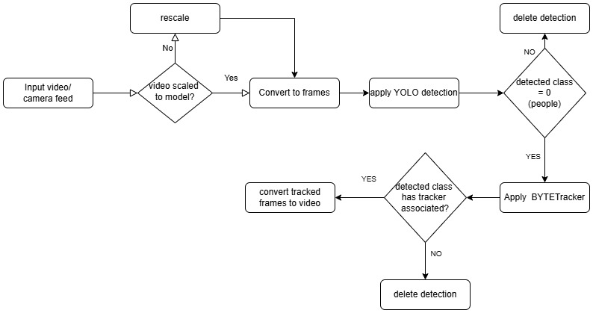

Fig.1: Methodology Implemented

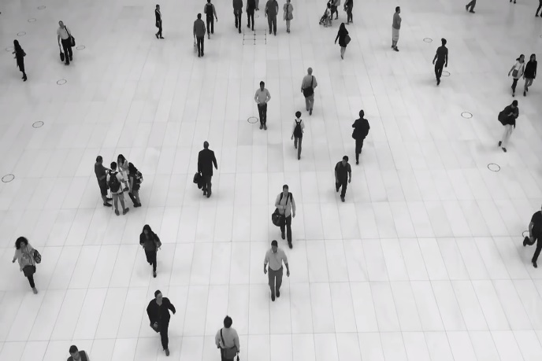
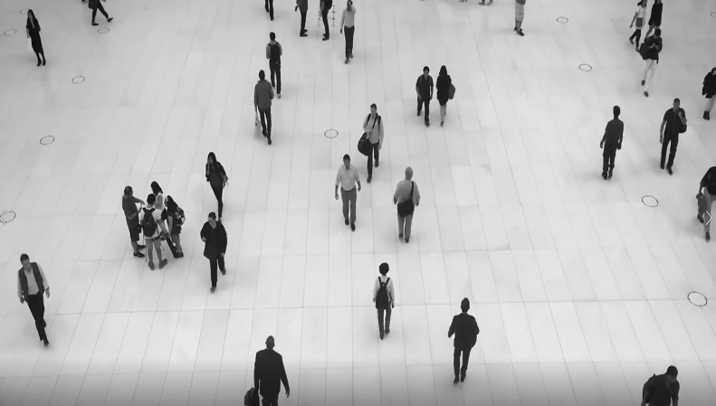

Fig.2: Input Video before Annotation
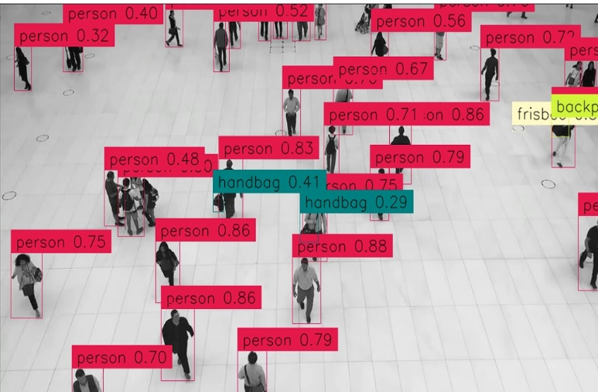
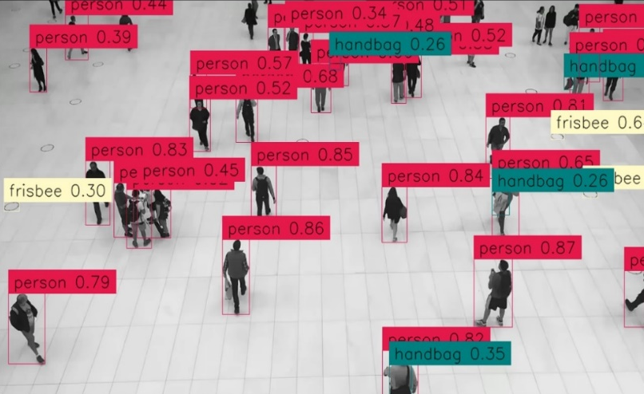

Fig.3: Video after Annotation

- Discussion
In this paper, we employed the ByteTracker algorithm in combination with the YOLOv8 model to efficiently track and examine crowd movement inside a certain area. Modern object identification model YOLOv8 was selected because of its exceptional accuracy and real-time performance. After that, a reliable multi-object tracking method called ByteTracker was used to keep track of these identified people consistently across a series of frames. The main goal is to count the number of objects entering and leaving a specific area, which was marked by a line inside the video frame. This line was the cutoff point for determining whether a movement was "in" or "out." ByteTracker for tracking and YOLOv8 for detection combined to create a dependable solution for people monitoring and counting in real-time circumstances. The output video effectively shows how our tracking system was put into practice. The main findings are:
1) Detection Accuracy: Even in crowded scenes, YOLOv8 reliably identifies objects inside the picture. Each object's bounding boxes are put precisely, demonstrating the model's high level of precision.
2) Tracking Consistency: ByteTracker successfully issues and keeps track of distinct IDs for every object it detects. Each individual object keeps a unique identity throughout frames, making it possible to precisely trace the motions, demonstrating this consistency.
3) Counting Mechanism: As objects cross the line, the "in" and "out" numbers are precisely updated. Counting logic operates as anticipated since the movement's direction is accurately interpreted.

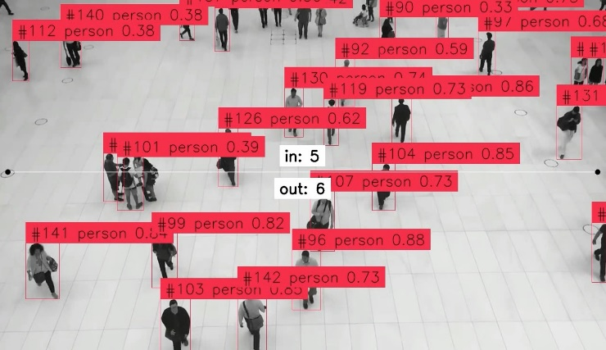
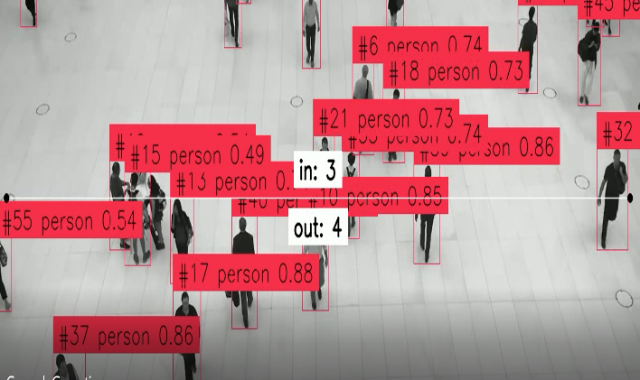

Fig.4: Output Video showing the count of people going in and out
- Limitations
  - Object Overlapping:
If an object overlaps another object throughout the scene, the ByteTracker system faces a challenge to track the overlapped objects. This happens because the overlapping object obstructs the view of the hidden object, making it difficult for the tracker to differentiate and accurately locate the object amidst the obstruction caused by the overlapping individual.

5.2 Heavy Computation:
The computation required for the proposed method is notably intensive, which poses limitations for its implementation on embedded systems. As a result, working on embedded systems will be posing a problem while implementing the algorithm in real-time.
- Scope of Improvement
Using two cameras instead of one camera which are placed opposite to each other. It will help in irradicating the chances of missing the count of the overlapping object and avoid misclassification. The second camera will allow us to view the alternate side of the feed. Thus, if one object is missed by one camera it will be captured by the second camera. Making the algorithm more robust.

If the placement of the second camera is not feasible may be due to the location or computational reasons. One can also use a Light Dependent Resistor (LDR) laser setup. This setup would be used to count the interruption in the laser source which will send a trigger that cross-validates the detection done by YOLO. The detected object can then be tracked through ByteTracker. This will ensure that not only all the desired objects are detected and tracked but will also ensure any anomaly in the object’s behavior. Such as an object moving multiple times through the laser.

- Benefits
Our goal is to reduce problems related to overcrowding in the day-to-day society. The frequent issues of over crowdedness arise at parking lots, shopping malls, movie theatres, and factories.

7.1 Societal:
To reduce problems related to crowdedness in day-to-day society in places such as parking lots, shopping malls, and movie theatres where in a parking lot the capacity is fixed and as the count keeps on increasing or decreasing the display will be updated showing parking full or parking available.

In a crowded place where there are multiple exits usually people tend to prefer the exit that is closest to them which in turn creates a problem by crowding the exits as a certain number of people enter the exit door the exit lighting will be off as soon as the required count is met.
7.2 Government:

The government can control traffic on load-constrained bridges by keeping track of the vehicles entering and exiting. Once the maximum number of vehicles is reached, they can reroute the traffic to different routes.

7.3 Business:
The factories can keep a track of many products are being manufactured and passing through the final conveyor belt. In poultry/dairy, we can keep a count of how many animals have currently gone for grazing and how many have returned.

- Conclusion
Using the methodology proposed in this paper, we were able to efficiently and effectively identify objects in a scene and filter out the objects that were not relevant, specifically focusing on people. Subsequently, we assigned a unique ID to each person detected in the frame and attached a tracker to each one. By implementing a mechanism to monitor the movement of these tracked objects across a designated line, we could determine the direction of movement and classify it as "in" or "out." This approach enabled us to successfully implement an intelligent model for crowd counting.

This resulted in high accuracy and efficiency in real-time object detection and tracking even in crowded scenes.
This methodology is a clear and straightforward way to count people entering or exiting a defined area, enhancing the practical application of our model in various real-world scenarios such as event management, retail analytics, and public safety.

In conclusion, we were able to demonstrate and implement the potential of advanced object detection and tracking methodologies in intelligent crowd-counting systems. The combination of effective filtering, unique identification, and directional tracking represents a significant advancement in the field, offering a scalable and accurate solution for real-time crowd monitoring with advancements in computational resources.
- References
- Object Detection | Papers With Code
- Z. -Q. Zhao, P. Zheng, S. -T. Xu and X. Wu, "Object Detection With Deep Learning: A Review," in IEEE Transactions on Neural Networks and Learning Systems, vol. 30, no. 11, pp. 3212-3232, Nov. 2019, https://ieeexplore.ieee.org/document/8627998.
- Zhang, Y. et al. (2022). ByteTrack: Multi-object Tracking by Associating Every Detection Box. In: Avidan, S., Brostow, G., Cissé, M., Farinella, G.M., Hassner, T. (eds) Computer Vision – ECCV 2022. ECCV 2022. Lecture Notes in Computer Science, vol 13682. Springer, Cham. https://doi.org/10.1007/978-3-031-20047-2_1
- [2401.17270] YOLO-World: Real-Time Open-Vocabulary Object Detection (arxiv.org)
- Joseph Redmon, Santosh Divvala, Ross Girshick, Ali Farhadi - You Only Look Once: Unified, Real-Time Object Detection. https://doi.org/10.48550/arXiv.1506.02640
- https://docs.ultralytics.com/
- Stephen Gould, Tianshi Gao, and Daphne Koller. 2009. Region-based s egmentation and object detection. In Proceedings of the 22nd International Conference on Neural Information Processing Systems (NIPS'09). Curran Associates Inc., Red Hook, NY, USA, 655–663.
- Chuyi Li, Lulu Li, Hongliang Jiang, Kaiheng Weng, Yifei Geng, Liang Li, Zaidan Ke, Qingyuan Li, Meng Cheng, Weiqiang Nie, Yiduo Li, Bo Zhang, Yufei Liang, Linyuan Zhou, Xiaoming Xu, Xiangxiang Chu, Xiaoming Wei, Xiaolin Wei - YOLOv6: A Single-Stage Object Detection Framework for Industrial Applications. https://doi.org/10.48550/arXiv.2209.02976.
- Joseph Redmon, Ali Farhadi - YOLOv3: An Incremental Improvement. https://doi.org/10.48550/arXiv.1804.02767.
- Jin Jie Ng, Kah Ong Michael Goh, Connie Tee - Traffic Impact Assessment System using Yolov5 and ByteTrack. https://journals.mmupress.com/index.php/jiwe/article/view/777/413.

